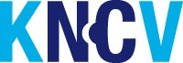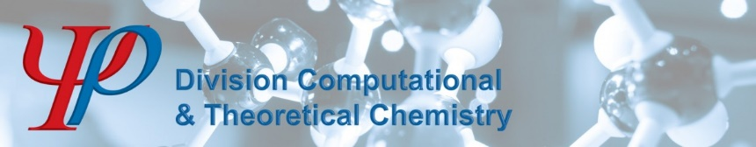

KNCV division Computational and Theoretical Chemistry

General Meeting of Members
May 12th 2025 15:00-15:50
Online

MINUTES

Meeting chair: Ivo Filot

1. Opening & Announcements

1a. Presentation new board members
Ferdinand Grozema and Herma Cuppen have recently vacated their board seats after completing their second three-year term. We are grateful for their dedicated service. We are now pleased to announce that Bernd Ensing and Evgeny Pidko have joined the board as new members.

1b. KNCV-CTC symposia
- The 2026 KNCV-CTC symposium will be held in Delft
- The 2027 KNCV-CTC symposium will be held in Utrecht

2. Approval of board discretionary spending limit
The board seeks to establish a spending threshold that does not require prior approval from the general assembly. The board proposes to set this discretionary spending threshold to 500 euros. The general assembly has approved the establishment of a discretionary spending threshold of 500 euros, below which the board does not require prior approval.

3. Approval of 2028 KNCV-CTC symposium in Maastricht
The board proposes to host the 2028 KNCV-CTC event in Maastricht, organized by Slava Vieru (UM) and Ivo Filot (TU/e). The general assembly has approved the board's proposal to host the 2028 KNCV-CTC event in Maastricht, to be organized by Slava Vieru (UM) and Ivo Filot (TU/e).

4. Integration of Chemoinformatics Workgroup
The board proposes to incorporate the chemoinformatics community as a workgroup within the CTC division. The general assembly has approved the integration of the cheminformatics community into the CTC division. To support this integration, one member from the cheminformatics community will be appointed to the CTC board. The community will be invited to determine how they wish to organize themselves within the division, with the understanding that the CTC division supports a one-year pilot period for their integration as a workgroup.

5. Any other business

6. Closing

